**Project Design Phase-II**

**Technology Stack (Architecture & Stack)**

|  |  |
| --- | --- |
| Date | 07 November 2022 |
| Team ID | PNT2022TMID10041 |
| Project Name | AI based discourse for Banking Industry |
| Maximum Marks | 4 Marks |

**Technical Architecture:**

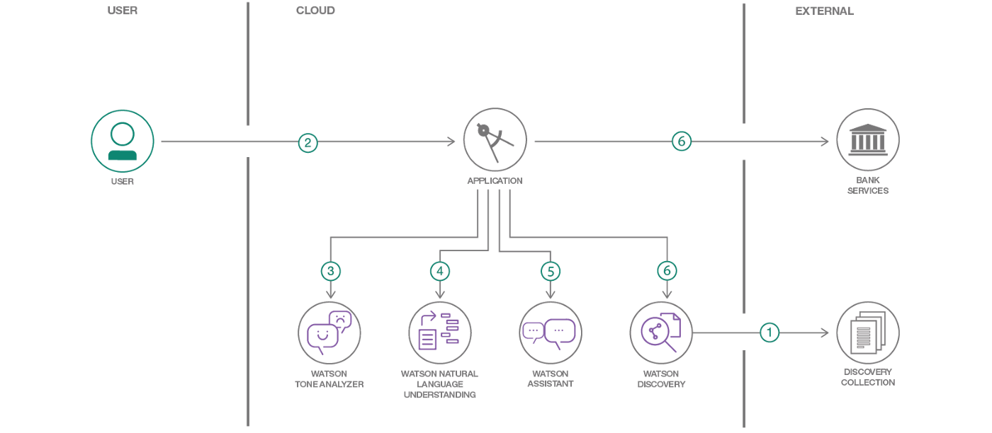

**Table-1 : Components & Technologies:**

|  |  |  |  |
| --- | --- | --- | --- |
| **S.No** | **Component** | **Description** | **Technology** |
| 1. | User Interface | Interface through which the user interacts with application. | Python / Flask |
| 2. | Application Logic-1 | The system is trained in such a way that it solves queries related to Savings Account | IBM Watson Assistant |
| 3. | Application Logic-2 | The system is trained in such a way that it solves queries related to Loan queries. | IBM Watson Assistant |
| 4. | Application Logic-3 | The system is trained in such a way that it solves queries regarding Net Banking and other general queries. | IBM Watson Assistant |
| 5. | Cloud Database | Database Service on Cloud | IBM DB2, IBM Cloudant. |
| 6. | Machine Learning Model | Machine learning models help in the process of enchancing chat bot responses. | Natural Languages Processing |
| 7. | Infrastructure (Server / Cloud) | Chatbot would be integrated to a flask web page and deployed on a Cloud Server | Local, IBM Cloud. |

**Table-2: Application Characteristics:**

|  |  |  |  |
| --- | --- | --- | --- |
| **S.No** | **Characteristics** | **Description** | **Technology** |
| 1. | Open-Source Frameworks | The proposed model is incorporated with Flask which is an open-source framework used for developing web applications using python, implemented on Werkzeug and Jinja2. | Flask |
| 2. | Security Implementations | IBM Cloud encrypts the data in database and storage services with built-in encryption. For higher levels of data protection, you can manage the encryption keys that encrypt the data at rest. For sensitive data, gain control of encryption keys by using Bring Your Own Key (BYOK) with IBM Cloud Key Protect. | IBM Cloud |
| **S.No** | **Characteristics** | **Description** | **Technology** |
| 3. | Scalable Architecture | The chat bot can be enchanced by creating and adding intents and by building dialog, action skills. | IBM Watson Assistant |
| 4. | Availability | The chat bot is made available 24 * 7 | IBM Watson Assistant |
| 5. | Performance | Watson Assistant provides customers with fast, consistent and accurate answers across any application, device or channel. Using AI, Watson Assistant learns from customer conversations, improving its ability to resolve issues the first time while removing the frustration of long wait times, tedious searches and unhelpful chatbots. | IBM Watson Assistant |